# Task 2 [For M2]

## Explanation and justification of each design of the methods and techniques

## Flowchart

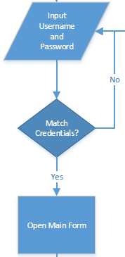Designed flowchart for event driven programming for given problem in scenario demonstrate basic flow of the system and its logic. In the designed flowchart (diagram1) when system starts, it asks user to input authentication information. Use of decision symbol means data inserted from user is first verified if it matches user information in database. If authentication matches main form of the system is opened else user is returned login page. This explanation is separately explained here in figure A.

Figure A

Now, after user is inside the system and controlling the main form, they are required to input choice in main form in order to access different features of the system as shown in figure B.

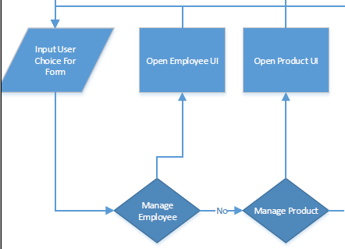

Figure B

User can return to main menu once they exit the opened form. If user wants to exit the system they have to choose either log off or exit. If user choose log off, they are logged out and login form opens. If they choose to exit, application ends.

Use of this tool to design the system demonstrates different features such as Employee, product etc. management of the system as well as basic security, flow of system etc. Here are some of the reasons to use this tool to design the system.

1. It is important tool for planning and designing new solution
2. It demonstrates flow of system
3. It provides overview of the system
4. It is easier to understand and provides basic platform to design the system.

## Context Diagram

Designed context diagram of the system in diagram 2 demonstrates basic concept of the system. It describes the main process of the system and its core features. Use of this tool helps to design the system in more depth level. This tool helps to understand the basic functions of the system.

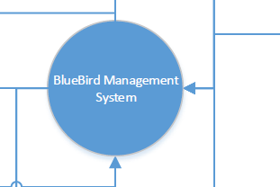In context diagram main process is described using circle symbol as shown in figure C.

Figure C

Now different features (entities) of the system and their relation with the process is demonstrated in the drawn context diagram. For example how system order and pay for the product to supplier and then supplier supplies the product to the system is demonstrated in figure D (part of drawn context diagram).

Here are some of the beneficial reasons to use context diagram tool to design the system.

1. No technical knowledge is required to understand the design
2. Provides overall view of the system
3. 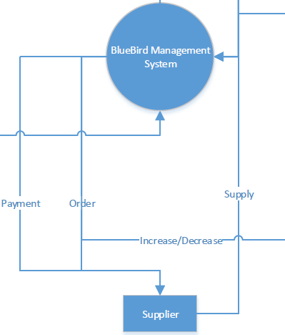Easy to draw.
4. Helps to design data flow diagram.

## Zero Level Data Flow Diagram (DFD)

Drawn zero level DFD (diagram 3) demonstrates different processes and external entities in the system.

It describes processed and their relation with entities, data storages, basic logic, data flow etc. This tool shows all the process of the system such as user login, product management, sales/purchase management etc. For example Figure E (part of drawn DFD) show how customer order the product and how system supplies the product to the customer.

Figure D

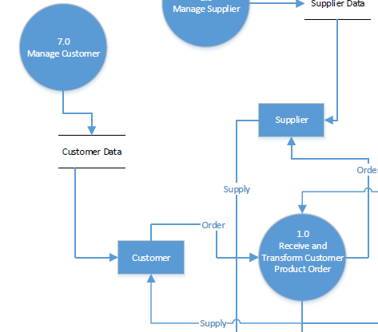Here in figure E information of customers in managed in process 7.0 (Manage Customer) and information is saved in data store named customer data. Once Customer order a product to process 1.0 it supplies to product to customer. Similarly this tools describes other functions of the system such as inventory management, employee management etc. Here are some of the beneficial reasons to use DFD tool to design the system.

Figure E

* A graphical technique easy to recognize.
* Provides a detailed representation of system
* Easier to understand by both technical and nontechnical stakeholders
* Demonstrates basic logic behind the data flow within the system.